## QUESTION 1

Assume you are given the tables below containing information on Snapchat users, their ages, and their time spent sending and opening snaps. Write a query to obtain a breakdown of the time spent sending vs. opening snaps (as a percentage of total time spent on these activities) for each age group.

Output the age bucket and percentage of sending and opening snaps. Round the percentage to 2 decimal places.

Notes, you should calculate these percentages:

1. time sending / (time sending + time opening)
2. time opening / (time sending + time opening)
3. To avoid integer division in percentages, multiply by 100.0 and not 100.

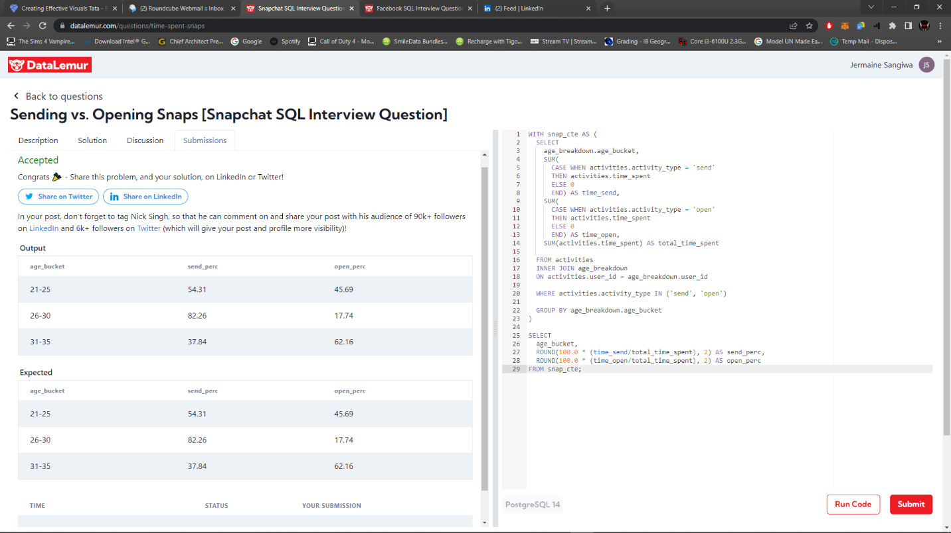

## QUESTION 2

Assume you are given the tables below about Facebook pages and page likes. Write a query to return the page IDs of all the Facebook pages that don't have any likes. The output should be in ascending order.

